Ebway Corporation ----- GRIPflow Sample Parts:
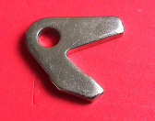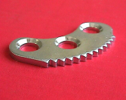
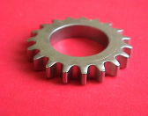
Made in a Compound Die. Material is a low carbon steel --- C1010. This part has been deburred and plated. One press stroke and the part is complete --- No Secondary Machining --- the hole was pierced --- not drilled --- the outside contour was stamped --- not machined. The part us used in a latching mechanism.
Made in a 3-Station Progressive Die. Material is a medium carbon steel --- C1035. This part has been deburred and plated --- no secondary machining --- all holes were pierced eliminating drilling, the countersinks were coined and the teeth were stamped --- not broached. The part is used in an automotive parking-brake assembly.
Made in 3-Station Progressive Tooling. Material is medium carbon steel --- C1050. This part has been deburred and plated --- the chamfer on each side of the teeth has been coined --- no secondary machining --- no hobbing --- no broaching. The part is used in an automotive engine timing mechanism.
Made in a Compound Die. Material is a low carbon steel -----C1010. This part has been deburred and plated --- no secondary machining --- note how close the holes are to the edge. The part is used in a computer printer assembly.
Made in a Compound Die. Material is a medium carbon steel --- C1050. This part has been deburred and plated ----- no secondary machining – the hole was pierced not drilled and the two raised portions were semi-pierced. The part is used in an automotive seat assembly.
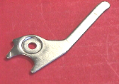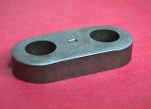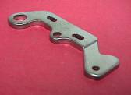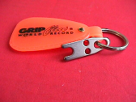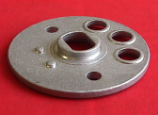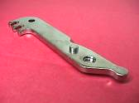
Made in Compound Die. Material is a low carbon steel --- C1010. This part has been deburred and plated. No secondary machining --- the holes close to the edge were pierced --- not drilled. The part is used in and automotive engine mounting bracket assembly.
Made in a 3-Station Progressive Tool. Material is 6061-O Aluminum. This part has been deburred and cleaned --- no secondary machining --- the holes were pierced --- not drilled/machined --- the “valve ports” were coined --- not machined. The center raised section was “drawn and coined”. The part is a valve plate used in a pneumatic power hand tool.
Made in 2-Station Progressive Tooling. Material is a low carbon steel --- C1010. This part has been deburred and plated. No secondary machining --- the hole was pierced and the counterbore was coined. The part is used in disk ejector assembly in the computer industry.
Made in 3-Station Progressive Tooling. Material is a medium carbon steel --- C4130. This part has been deburred and plated. No secondary machining --- the holes were pierced --- the countersinks were coined --- the step was coined. The part is used in a locking mechanism.

EBway Corporation ----- GRIPflow Sample Parts:

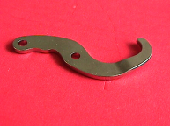
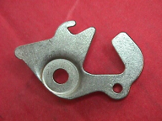

Made in Compound Die. Material is 300 series Stainless Steel. This part has been deburred --- no secondary machining --- note the jog was formed in the compound die offering better repeatability than secondary forms or progressive forms. The part is used in an assembly to weigh and grip fish.
Made in 2-Station Progressive Tooling. Material is low carbon steel --- C1010. This part has been deburred and plated --- no secondary machining --- all holes were pierced and the form was coined (note how close it is to the edge). The part is used in an automotive latch assembly.

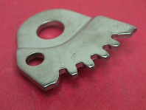

Made in Compound Die. Material is a medium carbon steel --- C1050. This part has been deburred and plated --- no secondary machining – all holes were pierced eliminating drilling -- the teeth were stamped eliminating broaching and the forming was done within the compound station producing exact repeatability. The part is used within an automotive seat assembly.

